SQL Analytical Queries & Views
1. Create and Populate Table
Query:-
CREATE TABLE Products (
ProductID INT PRIMARY KEY,
ProductName VARCHAR(50),
Price DECIMAL(10,2),
QuantitySold INT,
Category VARCHAR(50)
);
INSERT INTO Products (ProductID, ProductName, Price, QuantitySold, Category) VALUES
(1, 'Laptop', 800.00, 5, 'Electronics'),
(2, 'Smartphone', 600.00, 10, 'Electronics'),
(3, 'Desk Chair', 120.00, 15, 'Furniture'),
(4, 'Table', 200.00, 8, 'Furniture'),
(5, 'Notebook', 5.00, 20, 'Stationery'),
(6, 'Pen', 2.00, 50, 'Stationery');
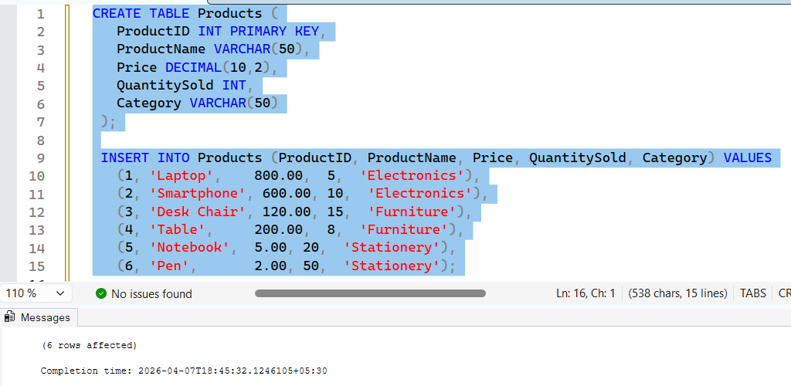

2. SQL Query Tasks
1. a) Above-Average Price: Select products whose Price exceeds the average price.
SQL:
SELECT * FROM Products
WHERE Price >(SELECT Avg(Price) FROM Products);
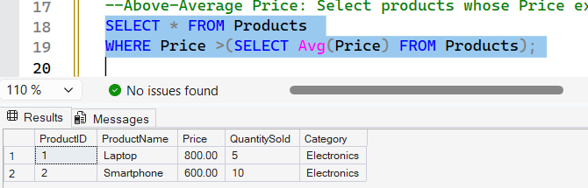

2. b) Most Expensive Product: Display the ProductName and Price of the highest-priced item.
SQL:
SELECT TOP 1 ProductName, Price FROM Products ORDER BY Price DESC;
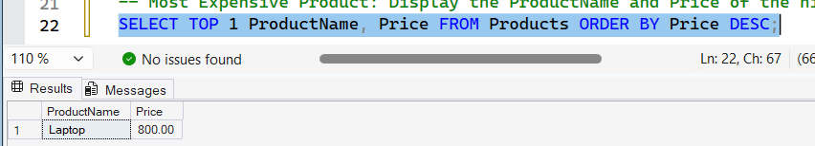

3. c) Category Counts: Show the total number of products in each Category (using a subquery).
SQL:
SELECT DISTINCT Category, (SELECT COUNT(*) FROM Products P2
WHERE P2.Category = P1.Category) AS ProductCount FROM Products P1;
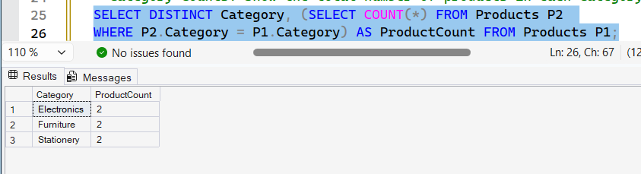

4. d) Below-Average Sales: Find products with QuantitySold below the average quantity sold.
SQL:
SELECT * FROM Products
WHERE QuantitySold < (SELECT AVG(QuantitySold) FROM Products);
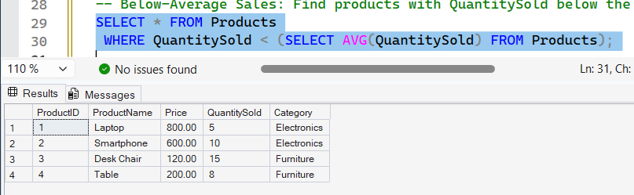

5. e) Electronics View: Create a view for all Electronics products.
SQL:
CREATE VIEW ElectronicsView AS
SELECT * FROM Products WHERE Category = 'Electronics';
